**[HashMap Custom implementation in java - How HashMap works internally with diagrams and full program](http://www.javamadesoeasy.com/2015/02/hashmap-custom-implementation.html)**

***1) Custom HashMap in java >***

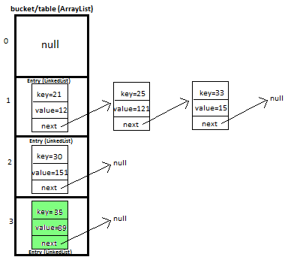

In this tutorial we will learn how to create and implement own/custom [HashMap](http://www.javamadesoeasy.com/2015/04/hashmap-in-java.html) in java with full working source code.

This is very **important** and **trending** topic in java. In this post i will be explaining **HashMap** custom implementation in lots of detail with diagrams which will help you in **visualizing** the HashMap implementation. ***This is must prepare topic for interview and from knowledge point of view as well.***

I will be explaining how we will **put** and **get** key-value pair in HashMap by overriding-

>**equals** method - helps in checking equality of entry objects.

>**hashCode** method - helps in finding bucket’s index on which data will be stored.

We will maintain **bucket (**[**ArrayList**](http://javamadesoeasy.com/2015/02/arraylist-custom-implementation.html)**)** which will store **Entry (**[**LinkedList**](http://javamadesoeasy.com/2015/01/doublylinkedlist-insert-and-delete-at.html)**).**

***2) Entry<K,V>***

We store key-value pair by using **Entry<K,V>**

Entry contains

* K **key**,
* V **value** and
* Entry<K,V> **next**(i.e. next entry on that location of bucket).

|  |
| --- |
| **static** **class** Entry<K, V> {         K key;         V value;         Entry<K,V> next;    **public** Entry(K key, V value, Entry<K,V> next){  **this**.key = key;  **this**.value = value;  **this**.next = next;         }     } |

*3) Putting* ***5 key-value pairs in own/custom HashMap (step-by-step)*** *in java****>***

I will explain you the whole concept of HashMap by putting **5 key-value pairs in HashMap.**

**Initially,** we have bucket of **capacity=4.** (all indexes of bucket i.e. 0,1,2,3 are pointing to null)

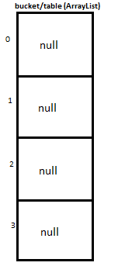

**Let’s put first key-value pair in HashMap-**

**Key=21, value=12**

**newEntry Object** will be formed like this >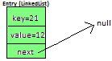

We will calculate hash by using our **hash(K key)** method **-** in this case it returns

**key/capacity= 21%4= 1**.

So, **1** will be the **index of bucket** on which **newEntry object** will be stored.

We will go to **1st** index as it is pointing to null we will **put our newEntry object there**.

At completion of this step, our HashMap will look like this-

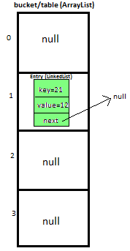

**Let’s put second key-value pair in HashMap-**

**Key=25, value=121**

**newEntry Object** will be formed like this >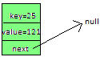

We will calculate hash by using our **hash(K key)** method - in this case it returns

**key/capacity= 25%4= 1.**

**So, 1** will be the **index of bucket** on which **newEntry object** will be stored.

We will go to **1st** index, it contains **entry with key=21**, we will compare two keys(i.e. **compare 21 with 25** by using **equals method**), as **two keys are different** we check whether entry with key=21’s **next is null or not**, **if next is null** we will **put** our **newEntry object** on **next.**

At completion of this step our HashMap will look like this-

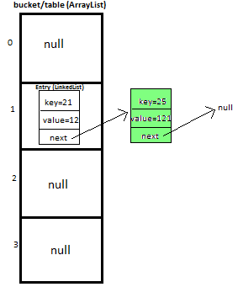

**Let’s put third key-value pair in HashMap-**

**Key=30, value=151**

**newEntry Object** will be formed like this >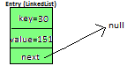

We will calculate hash by using our **hash(K key)** method **-** in this case it returns

**key/capacity= 30%4= 2**.

So, **2** will be the **index of bucket** on which **newEntry object** will be stored.

We will go to **2nd** index as it is pointing to null we will **put our newEntry object there**.

At completion of this step, our HashMap will look like this-

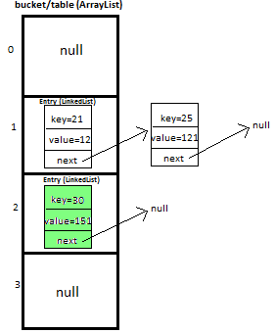

**Let’s put fourth key-value pair in HashMap-**

**Key=33, value=15**

Entry Object will be formed like this >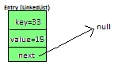

We will calculate hash by using our **hash(K key)** method - in this case it returns

**key/capacity= 33%4= 1,**

**So, 1** will be the **index of bucket** on which **newEntry object** will be stored.

We will go to **1st** index -

**>**it contains **entry with key=21**, we will **compare** two keys (i.e. **compare 21 with 33** by using **equals method**, as **two keys are different,**proceed to next  of **entry with key=21 (**proceed only if **next is not null).**

**>**now, next contains **entry with key=25**, we will **compare** two keys (i.e. **compare 25 with 33** by using **equals method**, as **two keys are different,**now **next of entry with key=25** is pointing to **null** so we won’t proceed **further,** we will **put our newEntry object on next.**

At completion of this step our HashMap will look like this-

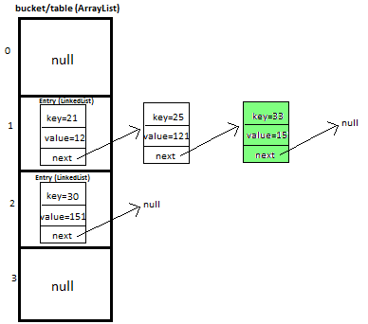

**Let’s put fifth key-value pair in HashMap-**

**Key=35, value=89**

**Repeat above mentioned steps.**

At completion of this step our HashMap will look like this-



**Must read:** [**LinkedHashMap Custom implementation**](http://javamadesoeasy.com/2015/02/linkedhashmap-custom-implementation.html)

[**LinkedHashMap Custom implementation -**](http://javamadesoeasy.com/2015/02/hashmap-custom-implementation-put-get.html) [**put, get, remove Employee object**](http://javamadesoeasy.com/2015/02/hashmap-custom-implementation-with.html)**.**

***4) Methods used in custom HashMap in java >***

|  |  |
| --- | --- |
| public void **put**(K newKey, V data) | -Method allows you put key-value pair in HashMap  -If the map already contains a mapping for the key, the old value is replaced.  -provide complete functionality how to override equals method.  -provide complete functionality how to override hashCode method. |
| public V **get**(K key) | Method returns value corresponding to key. |
| public boolean **remove**(K deleteKey) | Method removes key-value pair from HashMapCustom. |
| public void **display**() | -Method displays all key-value pairs present in HashMapCustom.,  -insertion order is not guaranteed, for maintaining insertion order refer [LinkedHashMapCustom](http://javamadesoeasy.com/2015/02/linkedhashmap-custom-implementation.html). |
| private int **hash**(K key) | -Method implements hashing functionality, which helps in finding the appropriate bucket location to store our data.  -This is very important method, as performance of HashMapCustom is very much dependent on  this method's implementation. |

*5) What will happen if map already contains mapping for key?*

If the map already contains a mapping for the key, the old value is replaced.

***6) Full Program/SourceCode for implementing custom HashMap*** *in java* ***>***

|  |
| --- |
| **package** com.ankit;  /**  * **@author** AnkitMittal, JavaMadeSoEasy.com  * Copyright (c), AnkitMittal . All Contents are copyrighted and must not be  * reproduced in any form.  * This class provides custom implementation of HashMap(without using java api's)-  * which allows us to store data in key-value pair form.  * insertion order of key-value pairs is not maintained.  * **@param** <K>  * **@param** <V>  */  **class** **HashMapCustom**<K, V> {    **private** Entry<K,V>[] table;   //Array of Entry.  **private** **int** capacity= 4;  //Initial capacity of HashMap    **static class Entry<K, V>** {         K key;         V value;         Entry<K,V> next;    **public** Entry(K key, V value, Entry<K,V> next){  **this**.key = key;  **this**.value = value;  **this**.next = next;         }     }       @SuppressWarnings("unchecked")  **public** HashMapCustom(){        table = **new** Entry[capacity];     }       /**      * Method allows you put key-value pair in HashMapCustom.      * If the map already contains a mapping for the key, the old value is replaced.      * Note: method does not allows you to put null key though it allows null values.      * Implementation allows you to put custom objects as a key as well.      * Key Features: implementation provides you with following features:-      *     >provide complete functionality how to override equals method.      *  >provide complete functionality how to override hashCode method.      * **@param** newKey      * **@param** data      */  **public void put(K newKey, V data)**{  **if**(newKey==**null**)  **return**;    //does not allow to store null.          //calculate hash of key.  **int** hash=hash(newKey);        //create new entry.        Entry<K,V> newEntry = **new** Entry<K,V>(newKey, data, **null**);          //if table location does not contain any entry, store entry there.  **if**(table[hash] == **null**){          table[hash] = newEntry;         }**else**{            Entry<K,V> previous = **null**;            Entry<K,V> current = table[hash];    **while**(current != **null**){ //we have reached last entry of bucket.  **if**(current.key.equals(newKey)){  **if**(previous==**null**){  //node has to be insert on first of bucket.                     newEntry.next=current.next;                     table[hash]=newEntry;  **return**;               }  **else**{                  newEntry.next=current.next;                  previous.next=newEntry;  **return**;               }           }           previous=current;              current = current.next;          }          previous.next = newEntry;         }     }     /**      * Method returns value corresponding to key.      * **@param** key      */  **public V get(K key)**{  **int** hash = hash(key);  **if**(table[hash] == **null**){  **return** **null**;         }**else**{          Entry<K,V> temp = table[hash];  **while**(temp!= **null**){  **if**(temp.key.equals(key))  **return** temp.value;              temp = temp.next; //return value corresponding to key.          }  **return** **null**;   //returns null if key is not found.         }     }     /**      * Method removes key-value pair from HashMapCustom.      * **@param** key      */  **public boolean remove(K deleteKey)**{    **int** hash=hash(deleteKey);    **if**(table[hash] == **null**){  **return** **false**;       }**else**{       Entry<K,V> previous = **null**;       Entry<K,V> current = table[hash];    **while**(current != **null**){ //we have reached last entry node of bucket.  **if**(current.key.equals(deleteKey)){  **if**(previous==**null**){  //delete first entry node.                     table[hash]=table[hash].next;  **return** **true**;               }  **else**{                     previous.next=current.next;  **return** **true**;               }           }           previous=current;              current = current.next;           }  **return** **false**;       }       }       /**      * Method displays all key-value pairs present in HashMapCustom.,      * insertion order is not guaranteed, for maintaining insertion order      * refer [LinkedHashMapCustom](http://javamadesoeasy.com/2015/02/linkedhashmap-custom-implementation.html).      * **@param** key      */  **public void display()**{    **for**(**int** i=0;i<capacity;i++){  **if**(table[i]!=**null**){                   Entry<K, V> entry=table[i];  **while**(entry!=**null**){                         System.*out*.print("{"+entry.key+"="+entry.value+"}" +" ");                         entry=entry.next;                   }            }        }       }     /**      * Method implements hashing functionality, which helps in finding the appropriate      * bucket location to store our data.      * This is very important method, as performance of HashMapCustom is very much      * dependent on  this method's implementation.      * **@param** key      */  **private int hash(K key)**{  **return** Math.*abs*(key.hashCode()) % capacity;     }  }  /**  * Main class- to test HashMap functionality.  */  **public class HashMapCustomApp** {    **public** **static** **void** main(String[] args) {            HashMapCustom<Integer, Integer> hashMapCustom = **new** HashMapCustom<Integer, Integer>();            hashMapCustom.put(21, 12);            hashMapCustom.put(25, 121);            hashMapCustom.put(30, 151);            hashMapCustom.put(33, 15);            hashMapCustom.put(35, 89);            System.*out*.println("value corresponding to key 21="                         + hashMapCustom.get(21));            System.*out*.println("value corresponding to key 51="                         + hashMapCustom.get(51));            System.*out*.print("Displaying : ");            hashMapCustom.display();            System.*out*.println("\n\nvalue corresponding to key 21 removed: "                         + hashMapCustom.remove(21));            System.*out*.println("value corresponding to key 51 removed: "                         + hashMapCustom.remove(51));            System.*out*.print("Displaying : ");            hashMapCustom.display();     }  }  **/*Output**  value corresponding to key 21=12  value corresponding to key 51=null  Displaying : {21=12} {25=121} {33=15} {30=151} {35=89}  value corresponding to key 21 removed: true  value corresponding to key 51 removed: false  Displaying : {25=121} {33=15} {30=151} {35=89}  */ |

***7) Complexity calculation of put and get methods in HashMap*** *in java* ***>***

***7.1) put*** *method -* ***worst Case*** *complexity >*

**O(n).**

**But how complexity is O(n)?**

Initially, let's say map is like this -



And we have to insert **newEntry Object** with **Key=25, value=121** 

We will calculate hash by using our **hash(K key)** method - in this case it returns

**key/capacity= 25%4= 1.**

**So, 1** will be the **index of bucket** on which **newEntry object** will be stored.

We will go to **1st** index, it contains **entry with key=21**, we will compare two keys(i.e. **compare 21 with 25** by using **equals method**), as **two keys are different** we check whether entry with key=21’s **next is null or not**, **if next is null** we will **put** our **newEntry object** on **next.**

At completion of this step our HashMap will look like this-



**Now let’s do complexity calculation -**

Earlier there was 1 element in HashMap and for putting **newEntry Object** we iterated on it. Hence complexity was O(n).

**Note**: We may calculate complexity by adding more elements in HashMap as well, but to keep explanation simple i kept less elements in HashMap.

***7.2) put*** *method -* ***best Case*** *complexity >*

**O(1).**

**But how complexity is O(n)?**

Let's say map is like this -



And we have to insert **newEntry Object** with **Key=30, value=151** 

We will calculate hash by using our **hash(K key)** method **-** in this case it returns

**key/capacity= 30%4= 2**.

So, **2** will be the **index of bucket** on which **newEntry object** will be stored.

We will go to **2nd** index as it is pointing to null we will **put our newEntry object there**.

At completion of this step our HashMap will look like this-



**Now let’s do complexity calculation -**

Earlier there 2 elements in HashMap but we were able to put **newEntry Object** in first go. Hence complexity was **O(1).**

***7.3) get*** *method -* ***worst Case*** *complexity >*

**O(n).**

**But how complexity is O(n)?**

Initially, let's say map is like this -



And we have to get **Entry Object** with **Key=25, value=121** 

We will calculate hash by using our **hash(K key)** method - in this case it returns

**key/capacity= 25%4= 1.**

**So, 1** will be the **index of bucket** on which **Entry object** is stored.

We will go to **1st** index, it contains **entry with key=21**, we will compare two keys(i.e. **compare 21 with 25** by using **equals method**), as **two keys are different** we check whether entry with key=21’s **next is null or not**, **next is not null** so we will repeat same process and ultimately will be able to get **Entry object**.

**Now let’s do complexity calculation -**

There were 2 elements in HashMap and for getting **Entry Object** we iterated on both of them. Hence complexity was O(n).

**Note**: We may calculate complexity by using HashMap of larger size, but to keep explanation simple i kept less elements in HashMap.

***7.4) get*** *method -* ***best Case*** *complexity >*

**O(1).**

**But how complexity is O(n)?**

Initially, let's say map is like this -



And we have to get **Entry Object** with **Key=30, value=151** 

We will calculate hash by using our **hash(K key)** method **-** in this case it returns

**key/capacity= 30%4= 2**.

So, **2** will be the **index of bucket** on which **Entry object** is stored.

We will go to **2nd** index and get **Entry object**.

**Now let’s do complexity calculation -**

There were 3 elements in HashMap but we were able to get **Entry Object** in first go.

Hence complexity was O(1).

***8) Summary*** *of complexity of methods in HashMap in java >*

|  |  |  |
| --- | --- | --- |
| Operation/ method | **Worst case** | **Best case** |
| *put(K key, V value)* | O(n) | O(1) |
| *get(Object key)* | O(n) | O(1) |